Software engineering for big data analaysis

CSA-1035

EXP NO:- 19

1. Draw an Activity diagram for Online Railway Reservation System using CASE tools that the two actors would be a customer and a ticket counter having search train, check availability of train, if “yes” then go to booking of train if “no” Quit the system model. Print details like make payment, print ticket, cancel ticket; refund ticket feed details like name of the passenger, date and time of journey, amount of the journey.

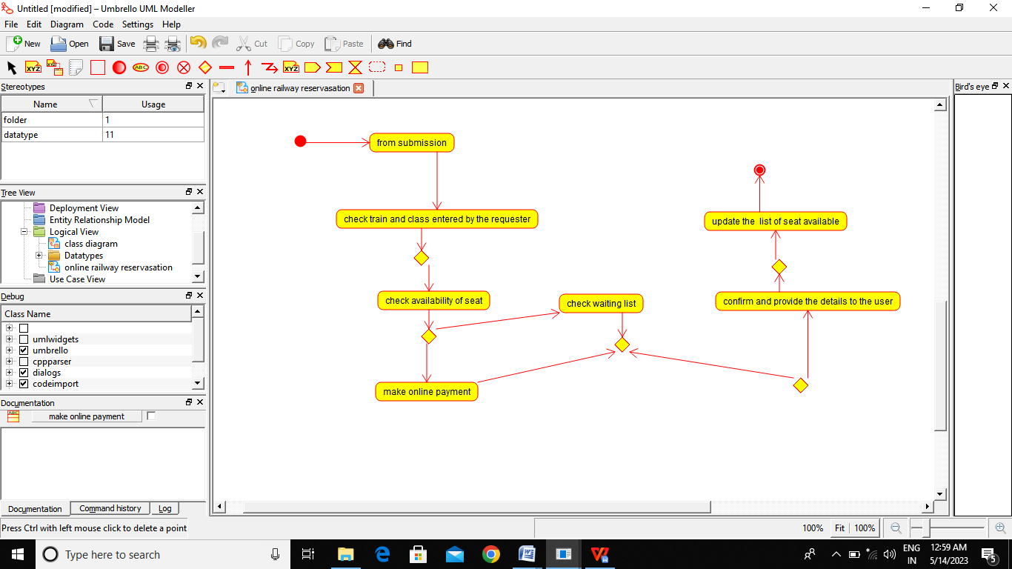

RESULT:-

Thus the Activity diagram for online Railway reservastion is drawn and verified successfully